**WEKA Cluster Analysis**

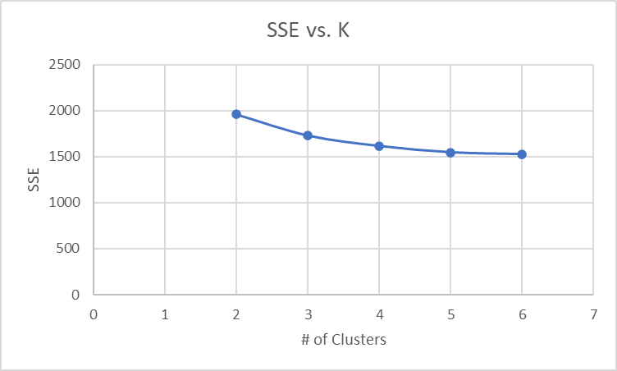

Scheme: weka.clusterers.SimpleKMeans -init 0 -max-candidates 100 -periodic-pruning 10000 -min-density 2.0 -t1 -1.25 -t2 -1.0 -N 5 -A "weka.core.EuclideanDistance -R first-last" -I 500 -num-slots 1 -S 10

Relation: BankCustomers

Instances: 600

Attributes: 10

age

genderOrJoint

region

income

married

children

auto_loan

save_act

ckg_acct

mortgage

Test mode: evaluate on training data

=== Clustering model (full training set) ===

kMeans

======

Number of iterations: 7

Within cluster sum of squared errors: 1545.204755989033

Initial starting points (random):

Cluster 0: 25, F, RURAL, '$14,505 ', NO, 3, NO, NO, YES, NO

Cluster 1: 61, J, RURAL, '$22,943 ',YES, 2, NO, YES, YES, NO

Cluster 2: 54, F, SUBURBS, '$31,096 ', YES, 2, NO, NO, YES, YES

Cluster 3: 36, J, DOWNTOWN, '$126,921 ', YES, 2, NO, NO, YES, YES

Cluster 4: 42, J, INNER_CITY, '$35,500 ', YES, 0, YES, NO, YES, YES

Missing values globally replaced with mean/mode

Time taken to build model (full training data) : 0.01 seconds

=== Model and evaluation on training set ===

Clustered Instances

0 195 ( 33%)

1 165 ( 28%)

2 50 ( 8%)

3 86 ( 14%)

4 104 ( 17%)

**Cluster Descriptions**

Cluster 0: Single Women in the City

* This group is low income ($32,000) living in the inner city. They are single moms around age 32 with one kid on average. They have a car loan and checking account but no savings or mortgage.

Cluster 1: Working Class Suburban Couples

* This group compromises of working-class couples around age 57 living in the suburbs. Combined income comes out to $51,000. They typically have one kid or none. They have checking and savings accounts but no mortgage or car loan.

Cluster 2: Divorced Suburban Moms

* This group consists of divorced suburban moms in their late 40s with one or more kids. They make $120,000 per year on average. They have checking accounts and mortgages but no savings or car loans.

Cluster 3: Young Professional Men

* These accounts are married men in their mid-30s with one or zero kids. They live downtown, make $130,000 on average, and have separate bank accounts from their spouses. They have no car loan or savings account. They do have checking accounts and mortgages.

Cluster 4: Suburban Families

* These accounts are suburban couples around age 45 with at least 2 kids. They make $88,000 on average and have car loans. They also have checking accounts and mortgages but no savings.

***Which customer segment would probably be most interested in opening a credit card account if Robert were to send them a promotional offer? Explain your reasoning***.

Suburban Families would be most interested in a credit card account. Mortgage payments, car payments, and multiple kids are very hard to pay for with only $88,000 annual income. Having a credit card would help pay for the expenses that come with having a house, two cars, and kids. The credit account will make it easier for the family to budget and pay weekly expenses. If a medical emergency were to occur, the credit card would give them a firm safety net if needed.